 

### Semester One Examination, 2017

### Question/Answer booklet

# MATHEMATICS

**METHODS**

**UNIT 3**

## Section One:

## Calculator-free

| Student Number: In figures |  |  |  |  |  |  |  |  |  |  |
| --- | --- | --- | --- | --- | --- | --- | --- | --- | --- | --- |

In words

Your name SOLUTIONS

TEACHER ______________________________________

## Time allowed for this section

Reading time before commencing work: five minutes

Working time: fifty minutes

## Materials required/recommended for this section

***To be provided by the supervisor***

This Question/Answer booklet

Formula sheet

***To be provided by the candidate***

Standard items: pens (blue/black preferred), pencils (including coloured), sharpener, correction fluid/tape, eraser, ruler, highlighters

Special items: nil

## Important note to candidates

No other items may be taken into the examination room. It is **your** responsibility to ensure that you do not have any unauthorised material. If you have any unauthorised material with you, hand it to the supervisor **before** reading any further.

## Structure of this paper

| Section | Number of questions available | Number of questions to be answered | Working  time (minutes) | Marks available | Percentage of examination |
| --- | --- | --- | --- | --- | --- |
| Section One:  Calculator-free | 8 | 8 | 50 | 51 | 35 |
| Section Two:  Calculator-assumed | 11 | 11 | 100 | 98 | 65 |
|  | | |  | **Total** | 100 |

## Instructions to candidates

1. The rules for the conduct of examinations are detailed in the school handbook. Sitting this examination implies that you agree to abide by these rules.

2. Write your answers in this Question/Answer booklet.

3. You must be careful to confine your response to the specific question asked and to follow any instructions that are specified to a particular question.

4. Additional working space pages at the end of this Question/Answer booklet are for planning or continuing an answer. If you use these pages, indicate at the original answer, the page number it is planned/continued on and write the question number being planned/continued on the additional working space page.

5. Show all your working clearly. Your working should be in sufficient detail to allow your answers to be checked readily and for marks to be awarded for reasoning. Incorrect answers given without supporting reasoning cannot be allocated any marks. For any question or part question worth more than two marks, valid working or justification is required to receive full marks. If you repeat any question, ensure that you cancel the answer you do not wish to have marked.

6. It is recommended that you do not use pencil, except in diagrams.

7. The Formula sheet is not to be handed in with your Question/Answer booklet.

**Section** **One: Calculator-****free** **35% (****51 Marks)**

This section has**eight (****8)** questions. Answer **all** questions. Write your answers in the spaces provided.

Working time: 50 minutes.

Question 1 (5 marks)

(a) (i)







(ii) 







**Question 2 (11 marks)**

(a)







(b)







(c) 



(d)

| Solution $\int{}\frac{4x^{3}+3}{x^{2}} dx$ = $\int{}4x+3x^{- 2} dx$ = $2x^{2}- \frac{1}{x^{3}}$ + c | |
| --- | --- |
| Marking key/mathematical behaviours | Marks |
| * correctly simplifies integral * correctly integrates each term | 1  1 |

(e)

| Solution $\int{}5{(2x-3)}^{3} dx$ = $\frac{5{(2x-3)}^{4}}{4 × 2}+c$ = $\frac{5}{8} {(2x-3)}^{4}+c$ | |
| --- | --- |
| Marking key/mathematical behaviours | Marks |
| * recognises the rule * correctly integrates | 1  1 |

**Question 3 (9 marks)**

(a)







(b) At











**Question 4 (5 marks)**

The graph below shows the curve $y=$ $\frac{180}{{\left(2x+5\right)}^{2}}$ and the line $x=5$.

Determine the area of the shaded region, enclosed by the $x-$ axis, the $y-$ axis, the line $x=5$ and the curve.

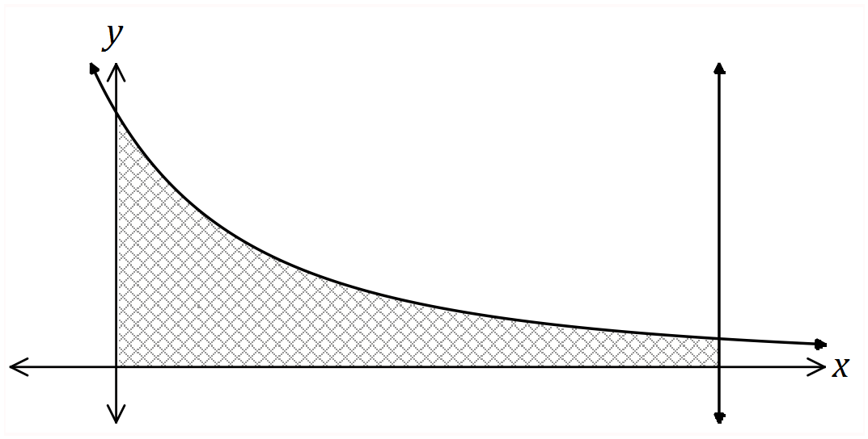

| **Solution** |
| --- |
| $A=\int_{0}^{5}{}{180\left(2x+5\right)}^{-2}dx={\left[{-\frac{180}{2}×\left(2x+5\right)}^{-1}\right]}_{0}^{5}=-90\left[\frac{1}{15}-\frac{1}{5}\right]=-90×\frac{-2}{15}=12 sq units$ |
| **Specific behaviours** |
| ✔ writes integral  ✔ antidifferentiates - correct power  ✔ antidifferentiates - correct multipliers  ✔ substitutes bounds  ✔ simplifies |

**Question 5 (6 marks)**

The graph of $y=f(x)$ is shown below, where $f\left(x\right)=e^{x}(x^{2}-3)$.

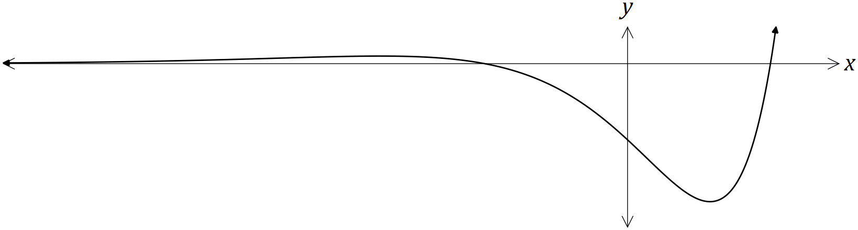

(a) Show that $f^{'}\left(x\right)=e^{x}(x^{2}+2x-3)$. (1 mark)

| **Solution** |
| --- |
| $f^{'}\left(x\right)=e^{x}\left(x^{2}-3\right)+e^{x}\left(2x\right)=e^{x}(x^{2}+2x-3)$ |
| **Specific behaviours** |
| ✔ indicates use of product rule |

(b) Determine the $x-$ coordinates of the stationary points of $f(x)$. (2 marks)

| **Solution** |
| --- |
| $e^{x}\left(x^{2}+2x-3\right)=0\left(x+3\right)\left(x-1\right)=0x=-3, 1$ |
| **Specific behaviours** |
| ✔ factorises  ✔ states $x-$ values |

(c) Given that $f^{''}\left(x\right)=e^{x}(x^{2}+4x-1)$, use the second derivative to justify that one of the stationary points is a local minimum and that the other is a local maximum. (3 marks)

| **Solution** |
| --- |
| $f^{''}\left(-3\right)=9-12-1=-4⇒Local maximum when x=-3$ $f^{''}\left(1\right)=1+4-1=4⇒Local minimum when x=1$ |
| **Specific behaviours** |
| ✔ clearly shows $f^{''}\left(-3\right)$ is $-ve$ ✔ clearly shows $f^{''}\left(1\right)$ is $+ve$ ✔ interprets signs of second derivative as required |

**Question 6 (6 marks)**

The table below shows the probability distribution for a random variable $X$.

It is known that $E\left(X\right)=1.7$ and .

|  |  |  |  |  |
| --- | --- | --- | --- | --- |
|  |  |  |  |  |

(a) Determine the values of the constants $a$ and $b$. (4 marks)

| **Solution** |
| --- |
| $4a+2b=1$ $0\left(a\right)+1\left(a+b\right)+2\left(b\right)+3\left(2a\right)=1.7$ $7a+3b=1.7$ $6a+3b=1.5$ $a=0.2, b=0.1$ |
| **Specific behaviours** |
| ✔ equation using sum of probabilities  ✔ equation using expected value  ✔ determines $a$ ✔ determines $b$ |

(b) Determine

(i) $E(3-2X)$. (1 mark)

| **Solution** |
| --- |
| $3-2\left(1.7\right)=-0.4$ |
| **Specific behaviours** |
| ✔ states value |

(ii) $Var(3-2X)$. (1 mark)

| **Solution** |
| --- |
| ${\left(-2\right)}^{2}\left(1.41\right)=5.64$ |
| **Specific behaviours** |
| ✔ states value |

**Question 7 (3 marks)**

(a) The function $f$ is such that $f\left(1\right)=-2$ and $f^{'}\left(x\right)=\sqrt{3+x^{2}}$. Use the increments formula to determine an approximate value for $f(1.05)$. (3 marks)

| **Solution** |
| --- |
| $y=f\left(x\right)⇒δy≈f^{'}\left(x\right)δx$ $x=1, δx=0.05$ $δy≈\sqrt{3+1^{2}}×0.05≈0.1$ $f\left(1.05\right)≈-2+0.1≈-1.9$ |
| **Specific behaviours** |
| ✔ identifies values of $x$ and $δx$ ✔ uses formula to calculate increment  ✔ calculates approximation |

**Question 8 (6 marks)**

The graph of $y=f(t)$ is shown below over the interval $0≤t≤10$.

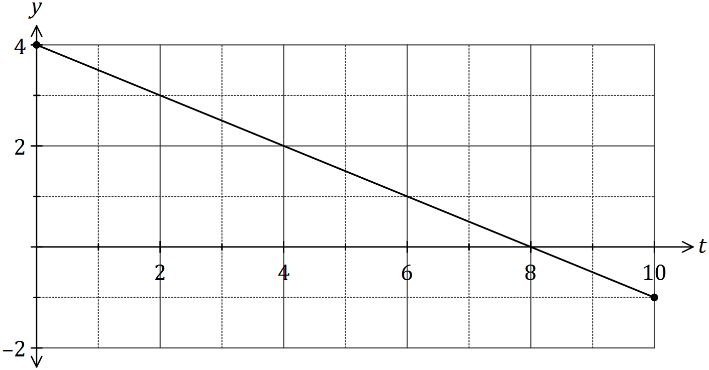

(a) Use the graph to determine an estimate for $\int_{0}^{2}{}f(t)dt$. (2 marks)

| **Solution** |
| --- |
| $\int_{0}^{2}{}f(t)dt=Area=\frac{4+3}{2}×2=7$ |
| **Specific behaviours** |
| ✔ indicates area calculation  ✔ correct estimate |

(b) On the axes below, sketch the graph of $y=F(x)$ for $0≤x≤10$, where $F\left(x\right)=\int_{0}^{x}{}f(t)dt$.

(4 marks)

| **Solution** |
| --- |
| See graph |
| **Specific behaviours** |
| ✔ starts at (0, 0) and includes (2, 7) from (a)  ✔ maximum at (8, 16)  ✔ endpoint close to (10, 15)  ✔ smooth parabolic shape |

